**GAIN Index 2012 Summary of changes**

# Abstract

The Global Adaptation Institute (GAIN) launched the GAIN Index September 14, 2011. Over the following year, the institute has focused on growing the user base and gathering feedback. GAIN has presented the index to public and private sector entities, as well as NGOs, academics and other stakeholders. The GAIN Index methodology and framework has remained unmodified since late August 2011. For the 2012 release GAIN has concentrated on a complete internal audit, fixing “bugs” and also supporting users of the index and gathering user feedback. Communications and fundraising around the index were also important focuses of GAIN. Following the recommendations from last year, GAIN has drafted additions to the index (indicators that measure ecosystem services and urban resilience). GAIN is also considering improving the Readiness Axis, but not for the 2012 release.

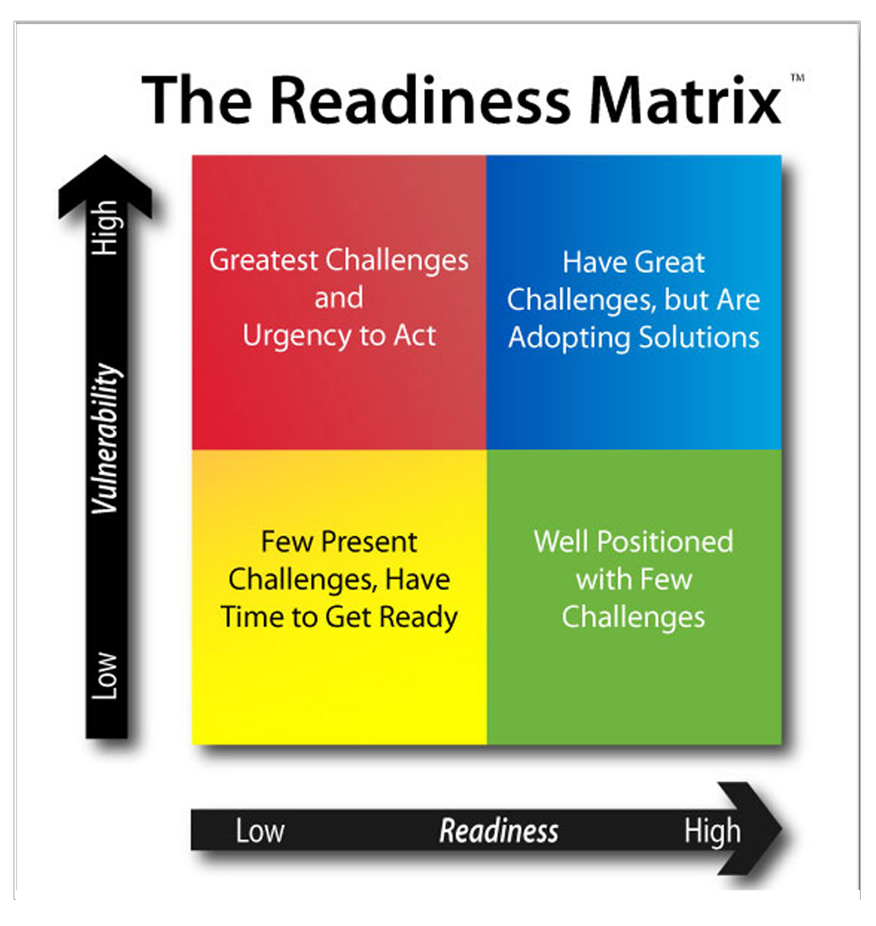

# Table of Contents

Abstract 1

Table of Contents 2

Feedback from roll-out 3

Index Website analytics 3

Presentations 5

Email and personal Feedback 6

GAIN Nomenclature of Versions 7

GAIN 2011 Legacy 7

GAIN 2012 Update 7

Changes in the code 8

Updates on Individual Measures 8

Re-sourced data 9

Tolerance for missing numbers 9

Preliminary Ranking 10

Differences in the Score for 2010 12

GAIN 2012 Upgrade 12

Specific Open Issues 13

Website update-upgrade 13

Readiness Axis 13

To Do 13

Next Steps 14

# Feedback from roll-out

## Index Website analytics

The Index website has a Google Analytics tracking code, which provides a lower estimate[1] for visits, and includes important information such as e.g. navigation flow, time per visit or source of the visit. Visits from inside the Institute´s IP network are not counted.

In the last year (from launch until Jul 24th) the GAIN Index web site has tracked 85,463 Page Views, with an average visit duration of 04m 41s and **2.90**

Page views per visit. This means around 30.000 visits, of which at least 20.000 are tracked as unique visitors.

**Visitor flow**

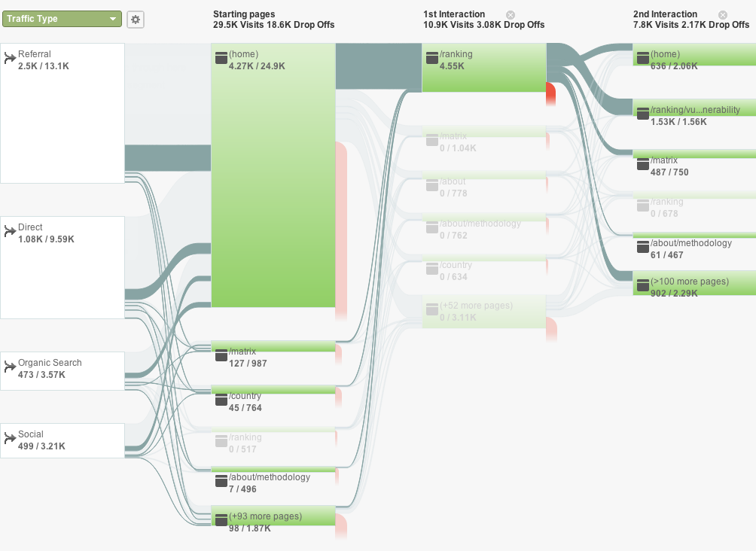

Figure 1 - Visitor flow. From left to right, the first column is the breakdown by entry type (referral, direct, organic or from social networks), the followings break down the pages visited. Lines between columns connect visitors to create the thread of usage. Red lines represent dropouts, or the end of the visit. The highlighted connecting path corresponds to those users who visit the Ranking page on their first interaction on the site. Numbers below each green block correspond to visits towards this highlighted path, versus total views.

From the visitor flow, we can read that the home page is the most visited page, and the biggest attractor is the Rankings.

Removing the month of the launch, where we peaked 12.000 pageviews following the launch event , our baseline is roughly 1.000 pageviews/week with a steady 50% of new visitors per week.

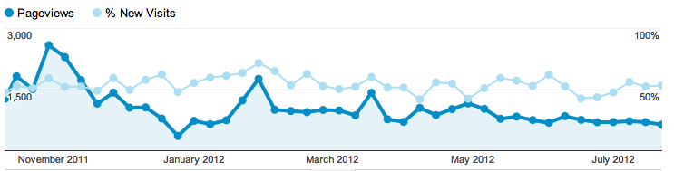

Figure 2 - Timeline of pageviews from October 2011 to July 2012 in dark blue, and faint blue for the percentage of new visits versus returning visitor.

Figure 1- Breakdown of pageviews on index.gain.org from Sep 2011 to July 2012.

Most of the views are of the front page, which is also the most common landing page, as we can also see on the flow chart. The GAIN Index Rankings page is the second most visited (12%), which confirms its importance (i.e. users are twice as interested in viewing the Rankings compared to the Methodology (5%)).

Figure 4- Traffic sources for index.gain.org from Sep 2011 to July 2012. The green section [gain.org / globalai.org] corresponds to the Institute´s page

Half of the traffic is direct, meaning visitors type the url address. Our organic sources (people searching related keywords in engines like Google) are steady around 17%. Interestingly two high-traffic websites alone have provided more inbound links than the organic search traffic.

Regarding search terms, the list includes obvious search terms such us “Global Adaptation Index”, “GAIN Index”. Other common entry keywords include terms such as “Adaptation Index” (our 9th most common entry keyword. We actually are in the first page for Google for that search query), and country specific profile pages (Chad number 10 in the top ranking of entry keywords), and Mongolia number 28, but also Denmark, Australia and the USA) all in the top 100 search terms.

The most common pathway is a referral to the front page, where the user is lead to the Rankings. The Matrix page is the second most common landing page, but with far fewer visits than the home page.

## Presentations

Given the focus on expanding the user base for the Index the Institute staff have been active in making presentations to a range of companies, consultancies and think-tanks, government and non-government institutions, and technical forums.

Summary of some of the presentation we have done since September 2011.

* Presentation with Calvert Investments, September 16, 2011, Bethesda, Maryland
* Panel discussion, *Rethinking Resiliency*, during NYC Climate week, September 21, 2011
* European Ideas Network in Bucharest, Romania, September 22, 2011
* Inter-American Development Bank, October 7, 2011, Washington, DC
* GAIN Index presentation, Tecnológico de Monterrey webcast throughout Latin America, November 3, 2011
* Carnegie Moscow Center, Carnegie Endowment for International Peace, Moscow, November 9, 2011
* GAIN Index Presentation to Latin American Ambassadors to the U.S., November 15, 2011
* Presentation to the UNFCCC Secretariat, Bonn Germany, November 15, 2011
* Meeting of international vulnerability experts, “Workshop on Vulnerability Indices,” Paris France, November 16, 2011
* World Bank, Asian Regions Experts, November 18, 2011
* Virtual Presentation to PepsiCo, Mexico, November 22, 2011
* Presentation to Caribbean Ambassadors to the U.S., OEA, Washington, DC, November 22, 2011
* Presentation to GRULA Ambassadors, Washington, DC, November 22, 2011
* *COP 17, UNFCCC climate negotiations* GAIN Index discussion, Durban, South Africa
* American University, November 30, 2011
* Presentation at IFC, January 27, 2012, Washington, DC
* *Is Latin America Ready to Cope with Climate Change? A Discussion of the Global Adaptation Index*, Inter-American Dialogue, Washington, DC, March 20, 2012
* *Engineers Without Borders-USA, Annual Meeting*, Henderson, Nevada, March 22, 2012
* *A Conversation on the Future of Central America*, Brookings Institution, Washington, DC, March 29, 2012
* *World Economic Forum on Latin America*, Puerto Vallarta, Mexico, April 16-18,
* *GAIN Annual Meeting & Scientific Convening*, Washington, DC, May 9 & 10
* *RIO + 20, UN Global Sustainability Conference*, Rio de Janiero, June 20, 2012
* *USAID, July, 2012*
* *State Department,* Office of Global Change, August, 2012

The Index also featured in a number of technical presentations dealing more broadly with the application of indices in adaptation planning, including meetings in Bonn, Tucson and Melbourne. A partial list of events can also be found here: <http://news.gain.org/tagged/events>

## Email and personal Feedback

We have compiled a list of ~40 Issues; i.e. questions from users at our presentations or via email regarding definitions, data sources, problems, data gaps, criteria and others. The list is available online at: <https://github.com/globalai/GaIn-Index/issues>. We are also listing how GAIN has resolved or intends to address the Issue (14 of those Issues are already fixed/closed).

# GAIN Nomenclature of Versions

Legacy Indices, updates and upgrades.

As it stands now we will have 3 sets of data:

* **GAIN Index 2011 Legacy**, with data from 1995 to 2010, which is the current website. Once we release this year´s update, there will be a link to a document explaining differences with the “GAIN Index Update” and “GAIN Index Upgrade”.
* **GAIN Index 2012 Update** from 1995 to 2011. This is the reference for comparisons with GAIN Index 2011 Legacy before adding the new measures.
* **GAIN Index 2012 Upgrade** from 1995 to 2011 (ecosystem services and urban additions). This will be the official GAIN Index.

# GAIN 2011 Legacy

The Index released last year in September will be referred as *Gain 2011 Legacy* once we launch the Gain 2012. The data will remain available, as well a summary of changes as described on this document.

The code, files and data that created GAIN 2011 Legacy will remain available here:

<https://github.com/globalai/GaIn-Index/tags>

The website source files and instructions for deployment will remain available here:

<https://github.com/globalai/Index-site/tags>

# GAIN 2012 Update

This version refers to the result of the Internal audit process. The framework remains the same, with the few changes outlined below. The resulting ranking is very similar to the GAIN 2011 Legacy, with the main following benefits:

* Data updated to include new information appearing in past year
* Code has been redone to ensure consistent results.
* More countries available.
* Re-Sourcing of the data, where some static measures are now dynamic (new temporal data).

## Changes in the code

The code has been completely reworked through an internal audit process. The conceptual framework remains the same, but a new computational approach was developed separate from the original code. All identified bugs in the Legacy code have been fixed, as reflected in the Issue tracker. The parameters for the framework (such as thresholds for each measure) remain the same.

The code is written in Microsoft Visual Basic. Available as a Macro under file Main.xls and also periodically copied here:

<https://github.com/globalai/GaIn-Index/blob/master/GAIN-main-code.vb>

## Updates on Individual Measures

Water Change in precipitation: No change; derived from current climate models

Water Use: Copied over from 2011

Water Access: Resourced from WB data portal.

Water Change in Temperature. Data from models. No change

Water Disease Copied over from 2011

Water Sanitation Re-sourced from WB data portal.

Agric Yld Projected Change Copied over from 2011

Agric rural popn Secondary measure (%)

Rural population Re-sourced from WB data portal.

Total Population Re-sourced from WB data portal.

Agric Capacity Secondary measure*

Fertilizers Re-sourced from WB data portal.

Machinery Re-sourced from WB data portal.

Irrigated Resourced from WB data portal.

Agric Yield CV Re-sourced from WB data portal.

Agric Imports Copied over from 2011

Agric Malnutrition Re-sourced from WB data portal.

Health DALYs Copied over from 2011

Health Staff Secondary (Total)

Health Physicians Re-sourced from WB data portal.

Health Nurses MW Re-sourced from WB data portal.

Health Longe Re-sourced from WB data portal.

Health Disease Copied over from 2011

Health External Re-sourced from WB data portal.

Health Maternal Re-sourced from WB data portal.

Coast Area Copied over from 2011

Coast Population Copied over from 2011

Energy Access Copied over from 2011

Energy Sensitivity Secondary. Re-sourced. Now is not static

Imports Re-Sourced from WB data portal.

Hydro Re-Sourced from WB data portal.

Road Floods Copied over from 2011

Road Paved Re-Sourced from WB data portal

R-IEF Business free Copied over from 2011 +1 column

R-IEF Finan free Copied over from 2011 +1 column

R-IEF Fiscal Free Copied over from 2011 +1 column

R-IEF Gov Spending Copied over from 2011 +1 column

R-IEF Invest Free Copied over from 2011 +1 column

R-IEF Monetary Free Copied over from 2011 +1 column

R-IEF Trade Free Copied over from 2011 +1 column

R-WGI psnv Re-Sourced from WGI data files.

R-WGI va.xls Re-Sourced from WGI data files.

R-WGI cc.xls Re-Sourced from WGI data files.

r-mobiles.xls Re-Sourced from WB data portal.

R-enrollment.xls Re-Sourced from WB data portal.

R-WGI rl.xls Re-Sourced from WGI data files.

R-IEF Labor Free.xls Copied over from 2011 +1 column

X-GDP pc.xls Re-Sourced from WB data portal.

\***Agricultural capacity:** We use 3 numbers, as before: Machinery use, Use of fertilizers and Irrigated land:

- 3/3 available numbers: Average of two best.  
- 2/3 available numbers: Average.  
- 1/3 available number: Insert N/A.  
- 0/3 available numbers: Insert N/A

## Re-sourced data

We have run comparisons of the input data (“Raw0”) used for the GAIN Index 2011 Legacy and the re-sourced data for the GAIN Index 2012 Update. In most cases we find none to few minor differences — no more than 5% of the numbers differ more than 10%. In three cases, however, differences were significant (we are investigating this Issue):

* Agricultural Malnutrition. Significant difference in about 50% of the data points were noted and traced to the use of data from an earlier attempt to derive information on malnutrition rather than from the WDI data as stated in the documentation.  This has now been corrected.
* World Development Indicators. There are differences scattered according to countries and year. Up to 40% of numbers differ 10% or more. Up to 10% differ more than 50%.
* Results for Agricultural Capacity are also off. Re-sourced data has scattered differences.

### Tolerance for missing numbers

Whenever a measure is not available for a particular year we use a standard algorithm to interpolate and/or extrapolate it. If no data are available for a country, the measure is dropped for that country.

Analyses while developing the 2011 index showed that a country could have up to a third of its measures missing as still have a reasonable estimate of its Index. In the 2012 Index we allow a quarter to a third of the measures to be missing for any component of the Index to be calculated.

For the 2012 index we propose a tolerance of ~75%, as shown on this table:

|  |  |  |
| --- | --- | --- |
|  | Components | **at least** |
| Water | 6 | 4 |
| Food | 6 | 4 |
| Health | 6 | 4 |
| Infrastructure | 6 | 4 |
| Exposure | 9 | 7 |
| Sensitivity | 9 | 7 |
| Capacity | 6 | 4 |
| Economic | 7 | 5 |
| Governance | 3 | 2 |
| Social | 4 | 3 |
| Vulnerability | 24 | 18 |
| Readiness | 14 | 10 |
| **GAIN Index** | 38 | 28 |

## Preliminary Ranking

The list below shows the rankings of the top 20 countries according to the “GAIN Index 2011 Legacy” (the current web ranking and with data up to 2010); the new Ranking, using the **preliminary** “GAIN Index 2012 Update” for 2010 and for 2011 (“GAIN 2012 Update” does not include the new sectors discussed in another paper). We were able to include more countries in the “GAIN Index 2012 Update”.

(see file *gain2012update-draft.xls* with all countries and scores)

|  |  |  |  |  |  |  |
| --- | --- | --- | --- | --- | --- | --- |
|  | “GAIN 2011 Legacy” | | “Gain 2012 Update” | | | |
| RANK | Country | 2010 | Country | 2010 | Country | 2011 |
| 1 | Denmark | 85.36 | Denmark | 84.84 | Denmark | 84.76 |
| 2 | Switzerland | 83.59 | Australia | 83.91 | Australia | 84.39 |
| 3 | Ireland | 82.24 | Norway | 81.97 | Norway | 82.18 |
| 4 | Australia | 82.03 | Switzerland | 81.01 | Switzerland | 81.56 |
| 5 | N. Zealand | 81.70 | Finland | 80.49 | Finland | 80.92 |
| 6 | Finland | 81.65 | N. Zealand | 79.99 | Ireland | 80.25 |
| 7 | Norway | 81.41 | Ireland | 79.79 | N. Zealand | 80.26 |
| 8 | USA | 80.01 | Austria | 79.26 | Austria | 79.70 |
| 9 | Germany | 79.98 | UK | 78.85 | UK | 78.92 |
| 10 | UK | 79.96 | Sweden | 77.65 | Sweden | 78.05 |
| 11 | Sweden | 79.75 | Singapore | 77.51 | Singapore | 77.74 |
| 12 | Czech R. | 79.70 | USA | 77.30 | Germany | 77.58 |
| 13 | Austria | 79.54 | Germany | 77.15 | USA | 77.63 |
| 14 | Netherlands | 79.21 | Chile | 76.74 | Romania | 77.20 |
| 15 | Iceland | 78.72 | Czech R. | 76.73 | Czech R. | 77.36 |
| 16 | France | 78.71 | Slovakia | 76.46 | Slovakia | 77.26 |
| 17 | Luxembourg | 78.53 | France | 76.31 | Chile | 76.53 |
| 18 | Poland | 78.23 | Iceland | 76.10 | Slovenia | 76.18 |
| 19 | Canada | 78.15 | Canada | 75.91 | France | 76.16 |
| 20 | Chile | 77.74 | Romania | 75.89 | Uruguay | 77.37 |

## 

## Differences in the Score for 2010

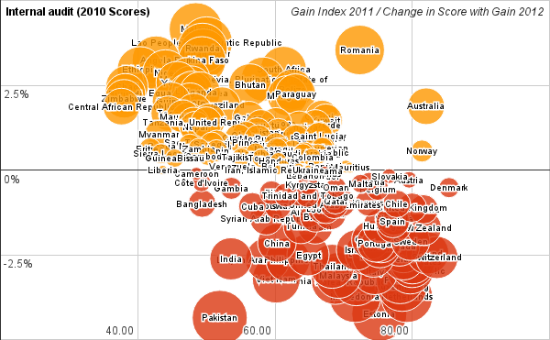

Figure 5 – Differences in Score between “Gain 2011 Legacy” and “Gain 2012 Update”. Horizontal axis is the “Gain 2011 Legacy” Score. Vertical Axis, and bubble size is the percentage change in Scores compared to “Gain 2012 Update”. Negative numbers (and red color) indicate less Score in the updated version.

The median change in scores is 0.10% (min -4.36%, max 4.15%). Several sources of these differences have been identified:

* Agricultural Capacity composite measure. We are investigating the issue.
* Re-sourcing of some of the measures includes updated or revised numbers and sometimes more data points, which means more countries can be included and less interpolation for existing countries.
* Fixing bugs such as one that allocated 0 vulnerability in Water Capacity to some countries.
* Slightly different, more consistent approach dealing with missing numbers.

We are still tracing the sources of the biggest differences to make sure the origin of these changes is known referenced, and understood.

# GAIN 2012 Upgrade

Following the Feedback received throughout the year, we are adding 2 additional measures for the Vulnerability Axis (Ecosystems and Settlements).

*Please see the document describing progress towards the inclusion of these measures.*

# Specific Open Issues

## Website update-upgrade

There are significant improvements suggested for the website. Some are feasible as additions to the current website framework, some are more suitable as an Excel file.

Suggested approach:

Some proposed website changes:

* Consistent use of matrix quadrant colors in maps.
* Improve the selection of similar countries for that tab by considering not only the overall score, but also neighboring countries, income group, etc.
* Add an ability to compare countries/sectors.
* Disaggregate dots in Matrix according to Sectors. This means the ability to place in the matrix the different components of each Axis (Exposure, Food, Economic, …)
* Filter countries by range of scores in selected sectors.
* Present histogram of values for Measures, to have an idea of the global spread of values.
* Resolve Rank ties within the chosen uncertainty in scores. In the current Ranking we only count one decimal point. New Zealand (5th in the ranking) and Finland (6th ) both have Score 81.7. Finland needs to be tied in 5th position, and Norway will keep it´s Rank (7th)

*Excel Version*: We are considering preparing a version of the Index in Excel format with more comparators and tools for advanced users.

## Readiness Axis

We also recognize the importance of revisiting the Readiness Axis. Feedback received in this regard suggests several directions to investigate. For example, a Readiness Structure separating *Policies* and *Outcomes*. In combination with the 3 current sectors (Economic, Government and Social) this would create a conceptual matrix similar to the Vulnerability Axis. There is also an Issue on how to treat and distinguish Adaptation Capacity (currently part of the Vulnerability Score) and some components of Readiness.

We need to explore all these possibilities, but we have decided to focus on the priorities listed in this document for the GAIN Index 2012.

## To Do

* Further explore differences with the Internal audit (and debugging).
* A few code modules are still missing (export to .csv, calculation of trends, GDP adjusted GAIN Index, Readiness and Vulnerability, Overall Internal correlations analysis)

# Next Steps

We are aiming to launch the Index in October. We thus propose the following tentative Road Plan:

* Consultation with the CoSA: 1-25 August.
* Consultation with extended group of users (Industry, Government, Universities, …): 10-25 August.
* Open Consultation: 25 August- 5 September.
* Design freezes. Prepare Final Numbers and Documentation: 5-15 September.
* Website Development: [Tentative] Second half of September.

1. Google Analytics uses JavaScript, which is not present, or blocked, in some computers. E.g. the estimation for these non-tracked cases in the US is around 3% of all Internet users. More information at: en.wikipedia.org/wiki/Google_Analytics